1. What is docker

Docker is open-source technology—and a container file format—for automating the deployment of applications as portable, self-sufficient containers that can run in the cloud or on-premises.

2.What is docker image

* A Docker container image is a lightweight, standalone, executable package of software that includes everything needed to run an application: code, runtime, system tools, system libraries and settings.
* Azure Docker Container. Log in to Azure Portal. Conclusion. Docker is a complete package that contains a bundle of sets of the application source code and its relevant configuration files and libraries, along with all its necessary dependencies for running the application.

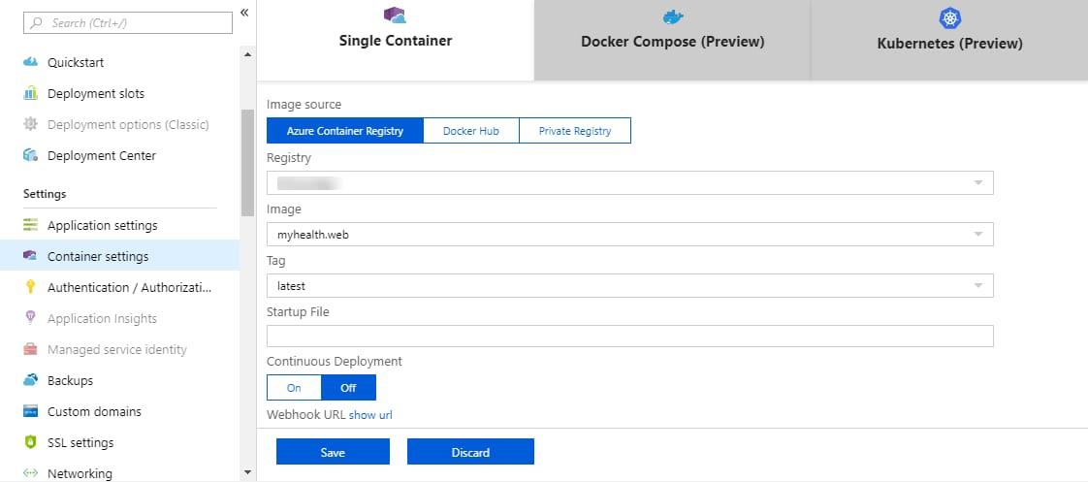

3.What is container

A stand and package of software –known as a container bundles as application’s code together with the related configuration fields and libraries, and with the dependencies required for the app to run. This allows developers and IT pros to deploy applications seamlessly across environments.

4. What is container registry

Azure Container Registry handles private Docker container images as well as related content formats, such as Helm charts, OCI artifacts, and images built to the OCI image format specification. Get started with OCI artifacts.

